**Automation Pre-requisites (Support center configurations)**

**Custom PC Agent Configuration:**

Community Name: Custom Automation

Sub-Community: Custom SubAutomation

**These settings are under sub community**

**Profile And Web settings: (For edit profile Tests)**

Name: Automation Profile Settings

**Contact Support Properties**

<p>You can contact Support using one of the following methods:</p>

<ul>

<li>Email: support@automation.com,</li>

<li>Phone: 100-200-3000</li>

</ul>

<p>Technical Support representatives are available to help you Monday

through Friday, 9:00 AM to 8:00 PM.</p>

**Address Fields**

Leave as default

**Optional Fields**

|  |  |  |  |
| --- | --- | --- | --- |
|  | **Field** | **Status** | **Default Value** |

Company Read-only Iron Mountain

Department Hidden -

Location Editable Bangalore

Employee ID Required -

**Custom Field**

|  |  |  |
| --- | --- | --- |
| **Field Label** | **Status** | **Default Value** |

Auto Custom Field Editable -

Leave Options as default

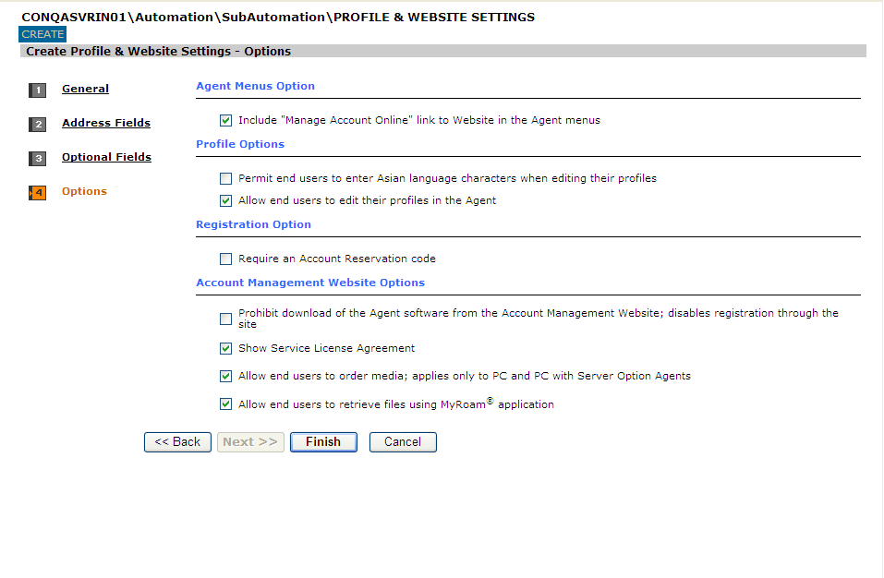

**Agent Version**

Create “Custom Auto Agent Version”

**Agent Settings**

General:

Name: “Custom Auto Agent Settings”

**Display**

**Leave default settings**

**Backup**

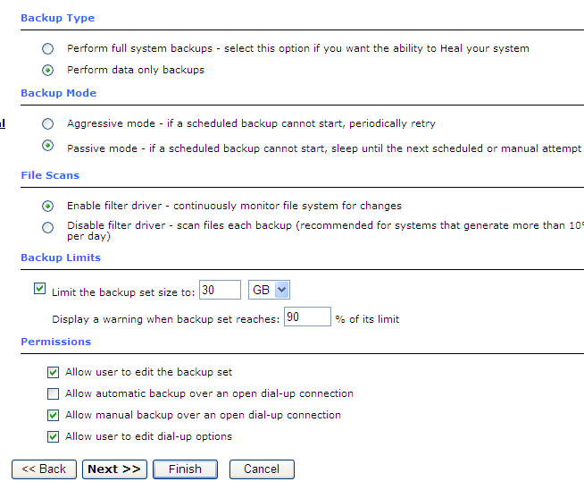

[**Schedule**](http://conqasvrin01/supportcenter/Detail.asp?type=43&amp;value=&amp;community=17&amp;menuchoice=1001)

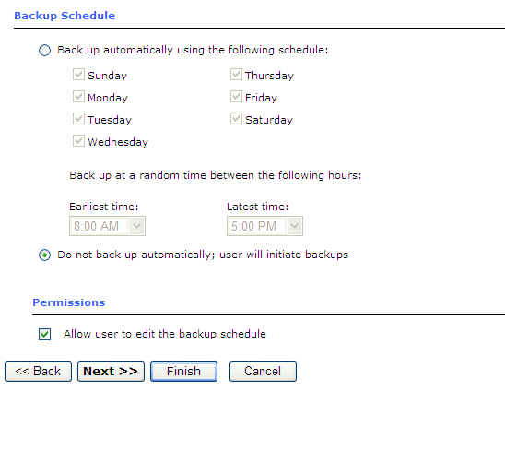

[**Retrieve/Heal**](http://conqasvrin01/supportcenter/Detail.asp?type=43&amp;value=&amp;community=17&amp;menuchoice=1001)

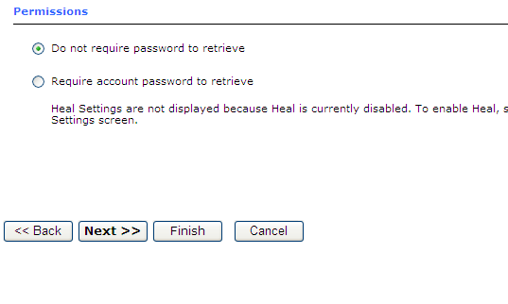

[**Proxy Server**](http://conqasvrin01/supportcenter/Detail.asp?type=43&amp;value=&amp;community=17&amp;menuchoice=1001)

* Do not use proxy server

**Agent Rule Set**

Create an “”Custom Auto Agent Rule Sets” rule with default

**PC Agent Configuration:**

Create a PC agent conmfiguration usign the Custom configurations created before..

Custom Auto PC Agent Configuration